Java SE Project

Training And Placement Application

***PtEditProfileFrame Documentation***

1. **PtEditProfileFrame -**

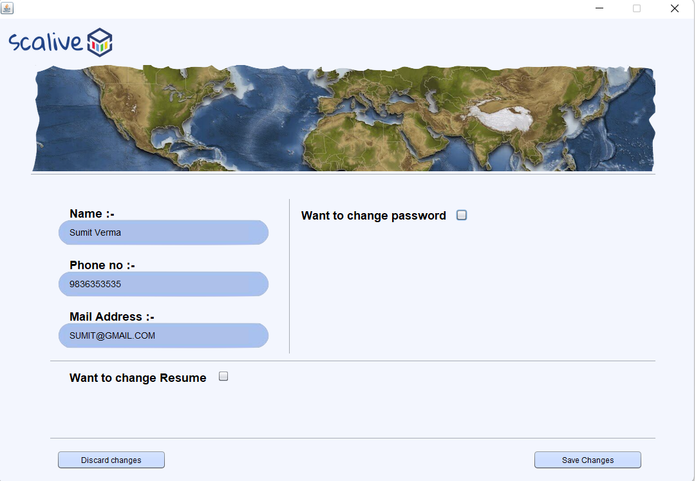

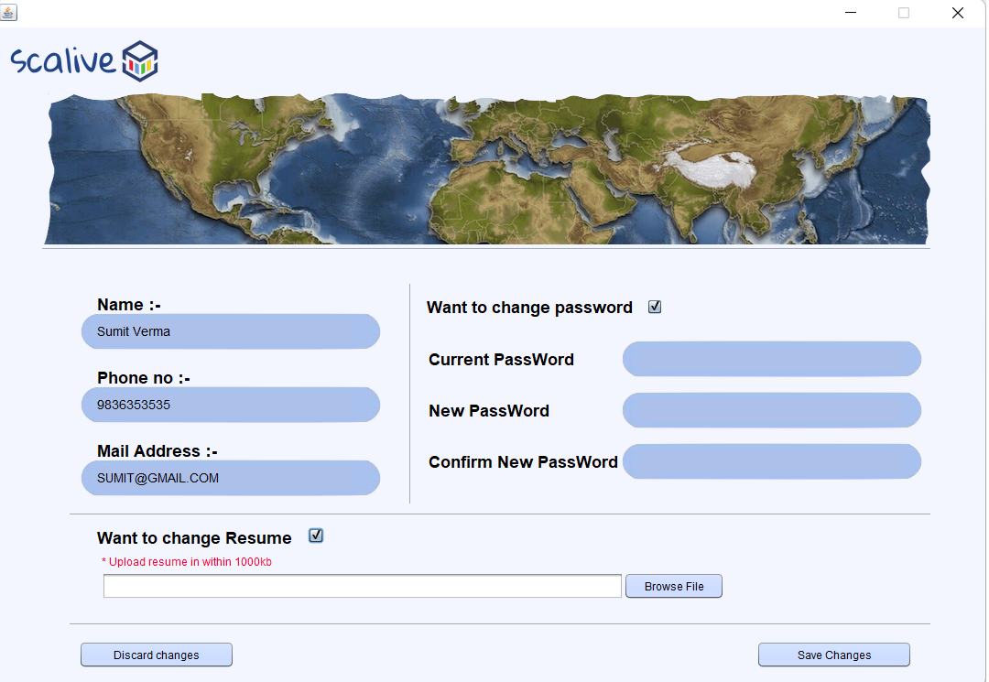

**WRITING THE CODE IN ParticipantDAO**

**Returning Particpant Details Based Upon Participant Id**

**public static ParticipantsPojo getParticipantById(String id)throws SQLException**

**The Code For getPartcipantById()**

**public static ParticipantsPojo getParticipantById(String id)throws SQLException**

**{**

**Connection conn=DBConnection.getConnection();**

**PreparedStatement ps=conn.prepareStatement("select name,userid,phone from users,participants where pid= id and pid=?");**

**ps.setString(1,id);**

**ResultSet rs=ps.executeQuery();**

**rs.next();**

**ParticipantsPojo pt=new ParticipantsPojo();**

**pt.setName(rs.getString(1));**

**pt.setUserId(rs.getString(2));**

**pt.setPhone(rs.getLong(3));**

**return pt;**

**}**

**Updating Resume Based Upon Participant Id**

**public static boolean updateResume(String userId,File file)throws SQLException**

**The Code For updateResume()**

**public static boolean updateResume(String pId,File file)throws SQLException,FileNotFoundException**

**{**

**PreparedStatement ps;**

**ps=DBConnection.getConnection().prepareStatement("update participants set resume=? where pid=?");**

**FileInputStream resume = new FileInputStream(file.getPath());**

**ps.setBlob(1,resume);**

**ps.setString(2,pId);**

**return 1==ps.executeUpdate();**

**}**

**WRITING THE CODE IN UserDAO**

**Checking Old Password**

**public static boolean checkOldPwd(String pId,String pwd)throws SQLException**

**The Code For checkOldPwd()**

**public static boolean checkOldPassword(String pId,String oldPwd)throws SQLException{**

**Connection conn=DBConnection.getConnection();**

**PreparedStatement ps=conn.prepareStatement("select * from users where password=? and id=?");**

**ps.setString(1, oldPwd);**

**ps.setString(2,pId);**

**ResultSet rs=ps.executeQuery();**

**return rs.next();**

**}**

**Updating Password**

**public static boolean updateParticipantPassword(String pId,String pwd)throws SQLException**

**The Code For updateParticipantPassword()**

**public static boolean updateParticipantPassword(String pId,String pwd)throws SQLException{**

**Connection conn=DBConnection.getConnection();**

**PreparedStatement ps=conn.prepareStatement("update users set password=? where id=?");**

**ps.setString(1, pwd);**

**ps.setString(2,pId);**

**return ps.executeUpdate()==1;**

**}**

**The Code For PtEditProfileFrame**

**public class PtEditProfileFrame extends javax.swing.JFrame {**

**private File file;**

**private String oldpwd,npwd,cnfpwd;**

**public PtEditProfileFrame() {**

**initComponents();**

**this.setLocationRelativeTo(null);**

**pwdPanel.setVisible(false);**

**resumePanel.setVisible(false);**

**loadData();**

**}**

**private void loadData(){**

**try{**

**ParticipantPojo pt=ParticipantDAO.getParticipantById(CurrentUser.getId());**

**txtName.setText(pt.getName());**

**txtMail.setText(pt.getUserId());**

**txtPhone.setText(pt.getPhone());**

**}**

**catch(SQLException ex){**

**JOptionPane.showMessageDialog(null,"DB Error In Edit Profile", "Error!!",JOptionPane.ERROR_MESSAGE);**

**ex.printStackTrace();**

**}**

**}**

**private boolean validateInputs(){**

**char []arroldpwd=txtPassword.getPassword();**

**char []arrnpwd=txtNewPassword.getPassword();**

**char []arrcnfrmpwd=txtCnfrmNewPassword.getPassword();**

**if(arroldpwd.length==0||arrnpwd.length==0||arrcnfrmpwd.length==0)**

**return false;**

**oldpwd=String.valueOf(arroldpwd);**

**npwd=String.valueOf(arrnpwd);**

**cnfpwd=String.valueOf(arrcnfrmpwd);**

**return true;**

**}**

**private boolean matchPasswords(){**

**return npwd.equals(cnfpwd);**

**}**

**}**

**private void chkPasswordActionPerformed(java.awt.event.ActionEvent evt) {**

**if(chkPassword.isSelected()){**

**pwdPanel.setVisible(true);**

**}**

**else{**

**pwdPanel.setVisible(false);**

**}**

**}**

**private void chkResumeActionPerformed(java.awt.event.ActionEvent evt) {**

**if(chkResume.isSelected()){**

**resumePanel.setVisible(true);**

**}**

**else{**

**resumePanel.setVisible(false);**

**}**

**}**

**private void btnBrowseActionPerformed(java.awt.event.ActionEvent evt) {**

**JFileChooser fileChooser=new JFileChooser();**

**fileChooser.setDialogTitle("Select Your Resume");**

**fileChooser.setFileSelectionMode(JFileChooser.FILES_ONLY);**

**int result=fileChooser.showOpenDialog(null);**

**if(result==JFileChooser.APPROVE_OPTION){**

**file=fileChooser.getSelectedFile();**

**txtFilePath.setText(file.getName());**

**}**

**}**

**private void btnDiscardActionPerformed(java.awt.event.ActionEvent evt) {**

**new ParticipantsOptionFrame().setVisible(true);**

**this.dispose();**

**}**

**private void btnSaveActionPerformed(java.awt.event.ActionEvent evt) {**

**boolean pwdChanged=false,resumeUpdated=false;**

**if(chkPassword.isSelected()){**

**if(validateInputs()==false){**

**JOptionPane.showMessageDialog(null, "Please Fill All The Fields","Empty Fields",JOptionPane.WARNING_MESSAGE);**

**return;**

**}**

**if(matchPasswords()==false){**

**JOptionPane.showMessageDialog(null, "Password And Confirm Password Do Not Match!","Password Mismatching",JOptionPane.WARNING_MESSAGE);**

**return;**

**}**

**try{**

**boolean resp=UserDAO.checkOldPassword(CurrentUser.getId(),oldpwd);**

**if(resp==true){**

**UserDAO.updateParticipantPassword(CurrentUser.getId(), npwd);**

**pwdChanged=true;**

**}else{**

**JOptionPane.showMessageDialog(null, "Your Old Password Is Wrong!","Password Mismatching",JOptionPane.WARNING_MESSAGE);**

**}**

**}**

**catch(SQLException ex){**

**JOptionPane.showMessageDialog(null,"DB Error In Edit Profile", "Error!!",JOptionPane.ERROR_MESSAGE);**

**ex.printStackTrace();**

**}**

**}**

**if(chkResume.isSelected()){**

**if(txtFilePath.getText().trim()!=""){**

**try{**

**ParticipantDAO.updateResume(CurrentUser.getId(), file);**

**resumeUpdated=true;**

**}**

**catch(SQLException ex){**

**JOptionPane.showMessageDialog(null,"DB Error In Edit Profile", "Error!!",JOptionPane.ERROR_MESSAGE);**

**ex.printStackTrace();**

**}**

**catch(FileNotFoundException ex){**

**JOptionPane.showMessageDialog(null,"File Error In Edit Profile", "Error!!",JOptionPane.ERROR_MESSAGE);**

**ex.printStackTrace();**

**}**

**}**

**}**

**if(pwdChanged && resumeUpdated){**

**JOptionPane.showMessageDialog(null, "Password & Resume Updated Successfully!","Success",JOptionPane.INFORMATION_MESSAGE);**

**}**

**else if(pwdChanged){**

**JOptionPane.showMessageDialog(null, "Password Updated Successfully!","Success",JOptionPane.INFORMATION_MESSAGE);**

**}**

**else if(resumeUpdated){**

**JOptionPane.showMessageDialog(null, "Resume Updated Successfully!","Success",JOptionPane.INFORMATION_MESSAGE);**

**}**

**else{**

**JOptionPane.showMessageDialog(null, "No Changes Done!!","Message!",JOptionPane.INFORMATION_MESSAGE);**

**}**

**}**